Type in this website to find some great games for children- to teach them how to type!

<http://interactivesites.weebly.com/typing.html>

* [**Home**](http://interactivesites.weebly.com/)
* **These are some of the great programs you will find!**
* [**Language Arts**](http://interactivesites.weebly.com/language-arts.html)
* [**Science**](http://interactivesites.weebly.com/science.html)
* [**Social Studies**](http://interactivesites.weebly.com/social-studies.html)
* [**Brainteasers**](http://interactivesites.weebly.com/brainteasers.html)
* [**Teacher Tools**](http://interactivesites.weebly.com/teacher-tools.html)

[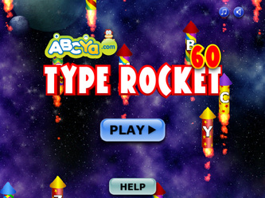](http://media.abcya.com/content/typing_rocket/typing_rocket.swf)

[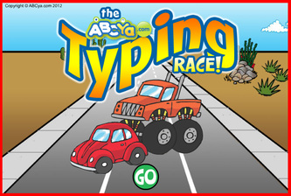](http://media.abcya.com/content/typing_race_cars/typing_race_cars.swf)

[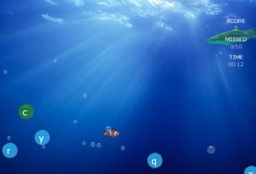](http://www.typingmaster.com/games/Bubbles.swf)

[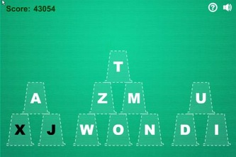](http://media.abcya.com/content/cup_stack_typing_game/cup_stack_typing_game.swf)

[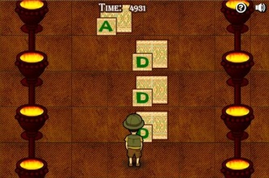](http://www.learninggamesforkids.com/keyboarding_games/jumping.swf)

[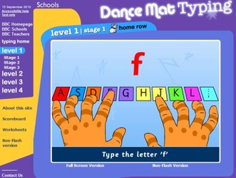](http://www.bbc.co.uk/schools/typing/)

[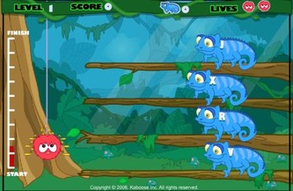](http://www.slimekids.com/games/typing-games/typingfiles/spider.swf)

[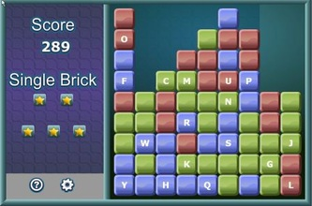](http://www.typingmaster.com/games/bricks.swf)

[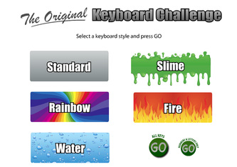](http://media.abcya.com/content/keyboard/keyboard.swf)

[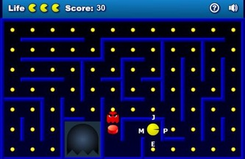](http://www.typingmaster.com/games/keyman.swf)

[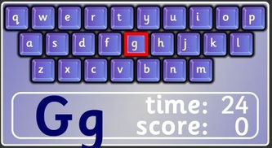](http://www.bigbrownbear.co.uk/keyboard/keys.swf)

[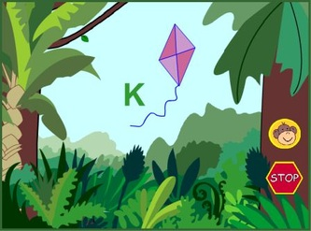](http://annrymer.com/keyseeker/)

[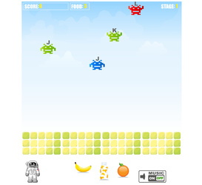](http://media.abcya.com/content/kids_typing_game/kids_typing_game.swf)

[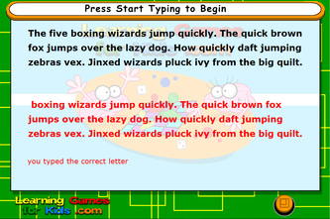](http://www.learninggamesforkids.com/keyboarding_games/typing1/preloaderTyping1.swf)