WASHINGTON PRIMARY NEWSLETTER

May 2017
Washington Primary School
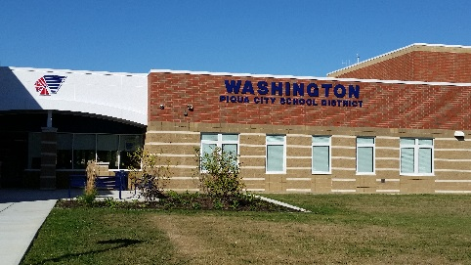

Upcoming Events
Week of May
MadCap Week
May 7
Rescheduled date for Piqua Educator Appreciation 5K

May 10
3rd Grade Field Trip

May 12
Field Day

May 26
Student’s Last Day - 2 Hour Early Dismissal (1:30 Dismissal Time)
3rd Grade Clap Out (1:00)

800 N. Sunset Drive
www.piqua.org T: 937-773-8472

MOVING?
Are you moving? If you will be moving over the summer and your child is planning to attend Springcreek Primary School, please let us know so we can better plan for your child’s transition. We want to make sure you receive correct information for the 2017-2018 school year over the summer. All third grade student records will be transferred to Piqua Central Intermediate School. Your help is greatly appreciated!
Library Books
Please be sure that your child turns in all library books so we can continue to have a strong collection of books for our students to check out. If you find a library book at home, we greatly appreciate your efforts to return it to our school. If your child has lost a library book, a fee for the lost book may be applied to your child’s school fees. Thank you so much for your help with this.
3rd Grade Clap out
We have a tradition that we clap out our 3rd graders on their last day of school as a way to recognize them for all of their hard work while at Washington Primary. We will be holding our 3rd Grade Clap Out at 1:00 PM on our last day of school (May 26th). We are asking 3rd grade parents who want to participate to come @ 12:45. We will have you help us line the hallway, and we will be dismissing our 3rd graders from the cafeteria area. If you wish, you can pick up your 3rd child from this area after the clap out. You will need to report to your child’s teacher if you are talking your child home after the clap out.

AVOID THE SUMMER SLIDE
The summer slide is a term used concerning how children lose skills while school is out. Students tend to forget some of what they have learned during the school year while they are out of school during the summer. You can use summer activities or time spent in the car to practice math, reading, or writing activities. After a trip to the zoo, you can give your child a journal to write about what they saw. As you are driving, your child can count the red and green lights and say what fraction each color represent of the total. You can sign your child up for the Piqua Library’s summer reading program and/or make sure that your child participates in Piqua’s Reading Program (more information to come!), by making sure your child reads at least 20-30 minutes a day. Ask your child to tell you about the books they are reading and talk to your child about your own reading, too!

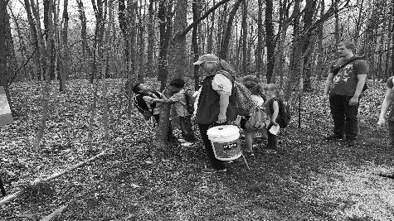

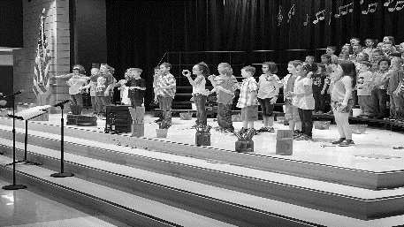

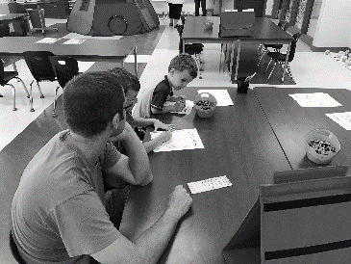

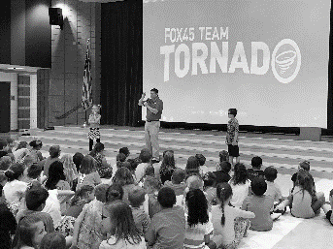

FEES AND LUNCH ACCOUNTS
Please make sure that your child’s school fees and lunch accounts are paid in full before the end of the school year. Any money that is left on a child’s lunch account will be carried over to the next school year. Students who owe outstanding fees will not receive a report card for the 4th quarter.
GRADE CARD PICK UP
4th Quarter Report Cards for Washington Primary students will be ready for parent pick up starting June 5th – June 7th at the Washington Primary Building between the hours of 9 AM – 2 PM. Any report cards that are not picked up will be mailed home.

Transportation Plans for 2017-2018

The Transportation staff is beginning to work on pre-routing for the coming year. We will begin taking transportation plan forms for the coming school year, beginning May 15, 2017. If you are unsure if you need to fill out a form, check the list below. If you are still unsure and need more information, please feel free to call the Transportation Office @ 773-1560. We will accept address changes and forms for our current students through July 31st but will need to stop accepting changes or forms, beginning August 1 in order to have the time to prepare bus routes. We plan to complete the routing process by August 14th for the start of Indian Days. Routing buses takes a solid two weeks so please have patience with us during this time since we will not have specific information ready until then. You may pick up forms at the Board Office or you may get a form online @ www.piqua.org.
Bus stop information will be available to parents and students beginning the evening of your child’s Indian Days event. Please do not call the school buildings for this information until after Indian Days is completed at your child’s building.
Which students need a new form filled out?
- Students who change addresses during the summer months.
- Students who need childcare, whether it is a sitter or a family member, at a location other than the student’s home.
- Students who have court ordered shared parenting. (A calendar will need to be filled out.)
- Students who are changing buildings for 2017-2018, who were formerly scheduled to walk.
- Students who need transportation who had been scheduled as parent transport in 2016-2017.
- Students who had formerly been riding and who no longer wish to ride.
Which students do NOT need a new form filled out?
- Students who have been scheduled at a home stop and do not wish to make a change.
- Students who had been scheduled as parent transport and do not wish to make a change.

Any changes turned in past July 31, will be routed as soon as possible but we cannot promise a schedule for Indian Days or on the first day of school. Once we are able to begin processing forms and changes again, they will be taken care of in the order they were received.
Forms for 2017-2018 will be available beginning May 15th on the homepage of the school website or at the board office.

